1. **Erlang** must be installed before installing RabbitMQ. For Erlang, MS Distribution is dependency. So install this too during installation.
2. 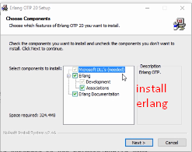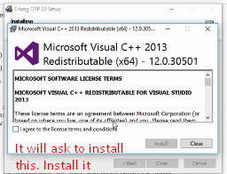
3. Now run **RabbitMQ server** installation.
4. Install RabbitMQ as service.
5. 